Frames

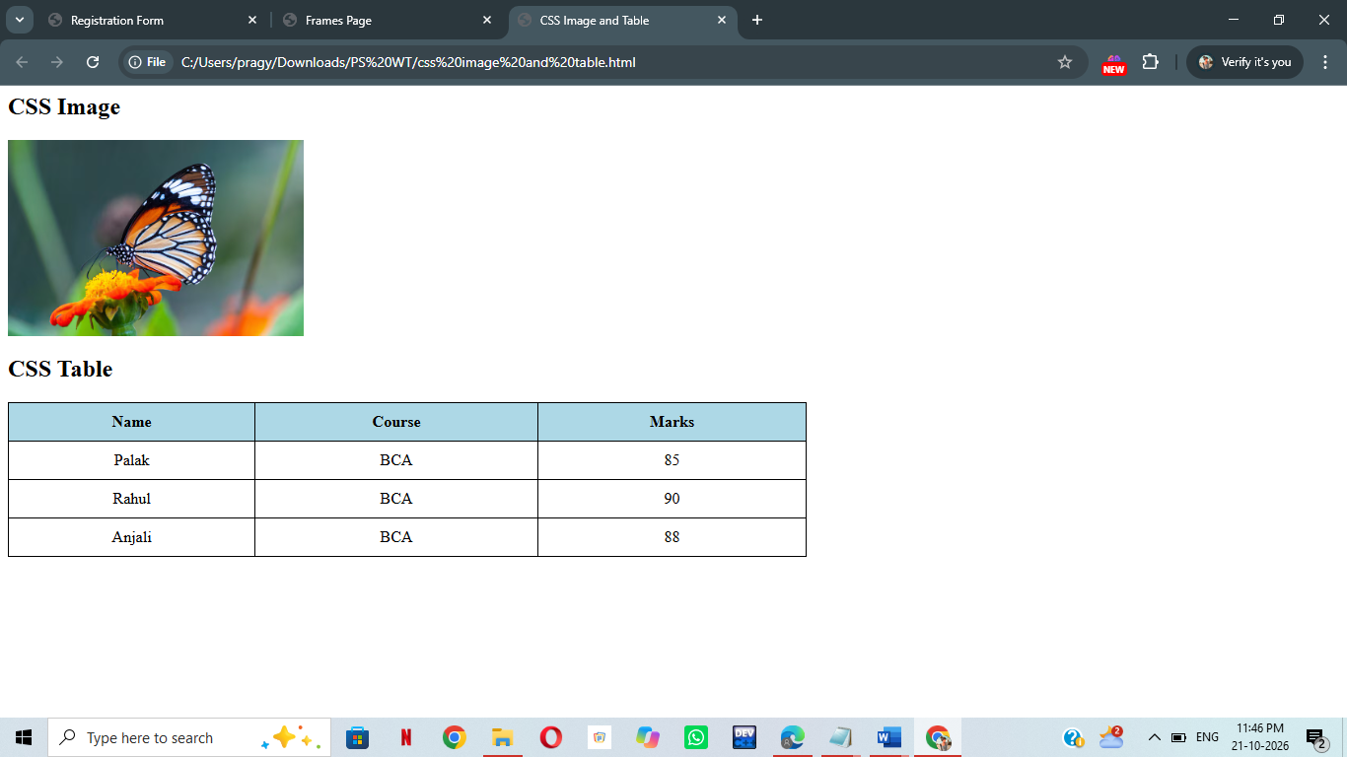

<html>
<head>
<title>CSS Image and Table</title>
<style>
img{width:300px;transition:0.5s;}
img:hover{transform:scale(1.1);opacity:0.8;}
table{width:60%;border-collapse:collapse;}
th,td{border:1px solid black;padding:10px;text-align:center;}
th{background-color:lightblue;}
tr{transition:0.3s;}
tr:hover{background-color:lightyellow;transform:scale(1.02);}
</style>
</head>
<body>
<h2>CSS Image</h2>
<img src="i1.avif" alt="Image">
<h2>CSS Table</h2>
<table>
<tr><th>Name</th><th>Course</th><th>Marks</th></tr>
<tr><td>Palak</td><td>BCA</td><td>85</td></tr>
<tr><td>Rahul</td><td>BCA</td><td>90</td></tr>
<tr><td>Anjali</td><td>BCA</td><td>88</td></tr>
</table>
</body>
</html>

